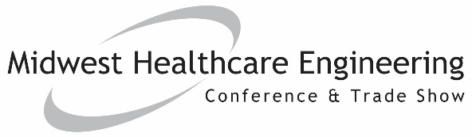
TO:
FROM:
SUBJECT: Why I should attend MWHCEC 2021
The 2021 Midwest Healthcare Engineering Conference & Trade Show is an educational and networking conference for more than 600 healthcare engineers and vendors from across the Midwest. I would like to request approval to attend.
The conference offers two days of educational sessions that focus on maximizing facility efficiency, staying compliant with current codes and how facilities can improve the environment of care. The third day includes a Certified Healthcare Facility Manager exam preparation course. These sessions will address the issues that we face and inform us how to implement and achieve optimal outcomes within our organization. Additionally, the event offers a trade show that provides access to nearly 100 vendors who specialize in helping healthcare facilities operate more efficiently.
This event is an opportunity for me to network with other healthcare engineers, as well as meet hundreds of vendors to find out how their latest developments will benefit us. Additionally, I can earn up to 10.5 continuing education credits for attending.
This event runs from Nov. 8-10 in Indianapolis. The conference agenda can be found here.
Here are the goals I plan to accomplish:
- Enter Goal 1
- Enter Goal 2
- Enter Goal 3
I have calculated an approximate breakdown of costs associated with my attendance:
Convention Registration | $
Optional additional registration: Certified Healthcare Facility Manager Exam Course (Nov. 10) | $
Accommodations estimate | $
Flight or mileage estimate | $
Total | $
I believe my attendance at MWHCEC will provide our facility with a strong ROI. Once I return, I can provide a report of my key takeaways, and share new trends and lessons with the team. I will work to make sure we get the full value of this event.
Thank you for your consideration.
Sincerely,
Your Name Here

